BigAivot Design Flow

LANDING PAGE
Landing page on BigAivot.com
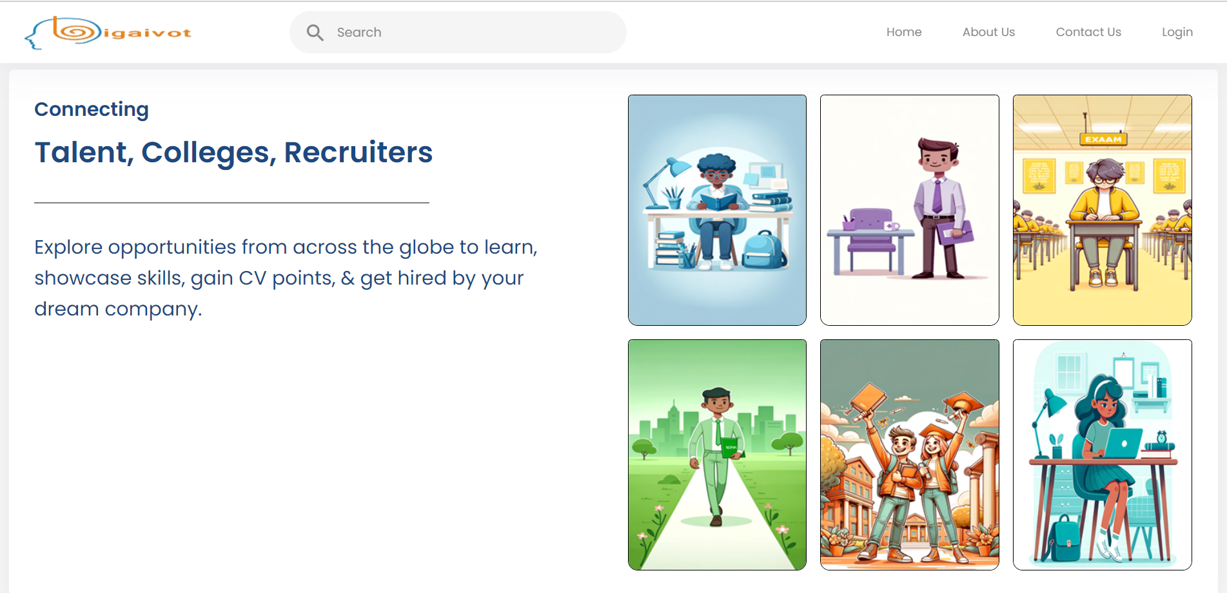

- Landing Page Content:
  - Header Menu:

    - Home
    - About Us
      - Content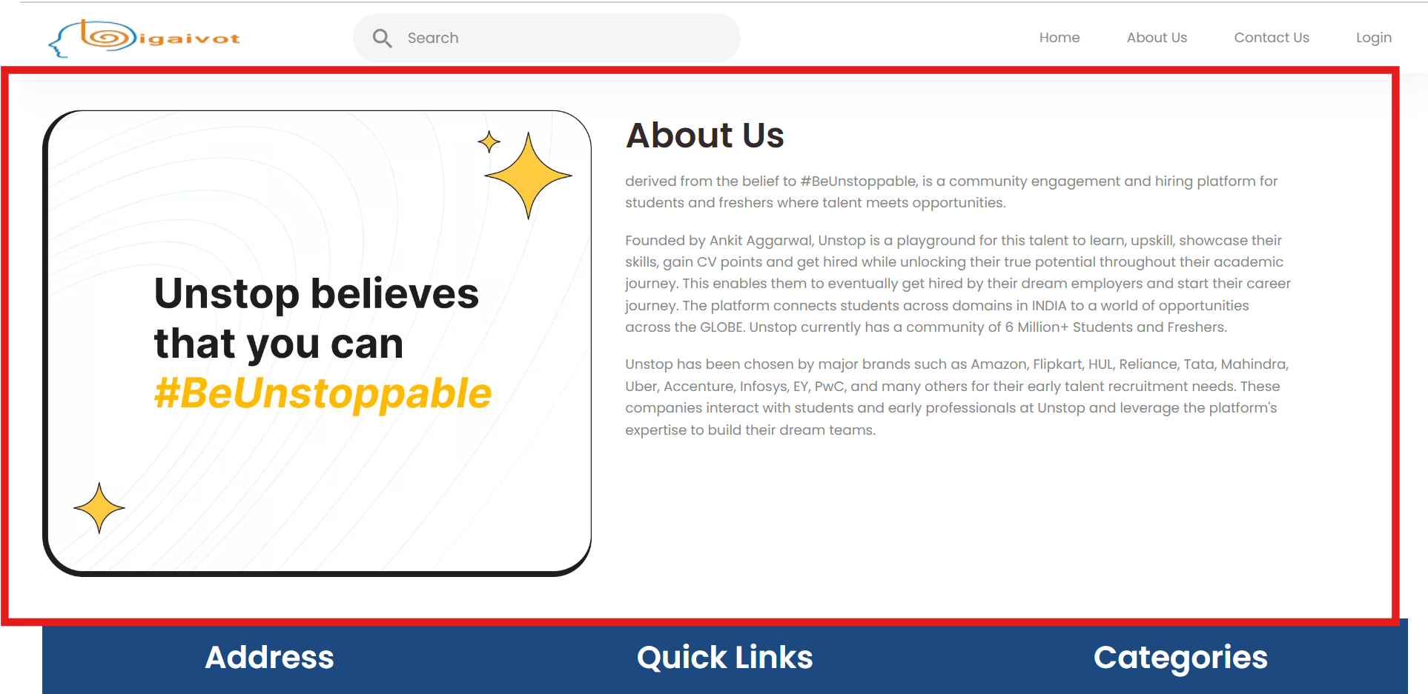
    - Contact Us
      - Content
      - Contact information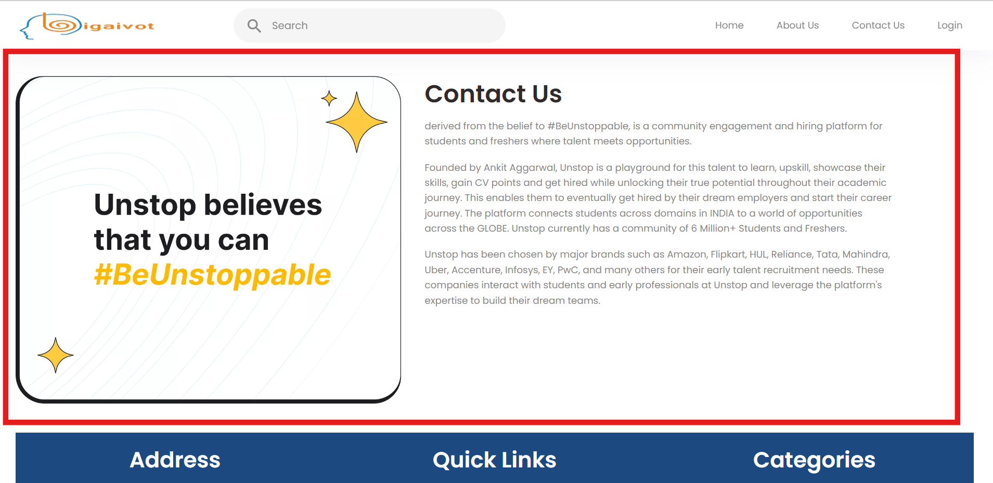
    - Login
      - Sign up only as an user for any other logins or account creation they user must contact the Super admin in the Contact us page.
      - Sign-Up page
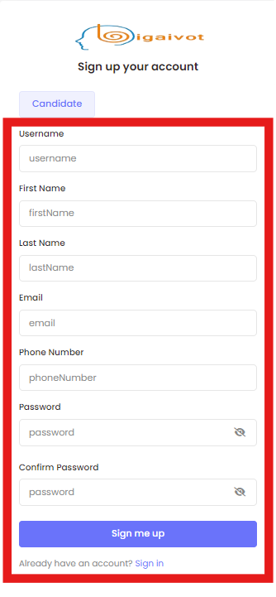
      - Fields:
        - Firstname
        - Lastname
        - DoB
        - Email ID
        - Country Code:
        - Phone number
        - Password
        - Confirm Password
      - Login Page:
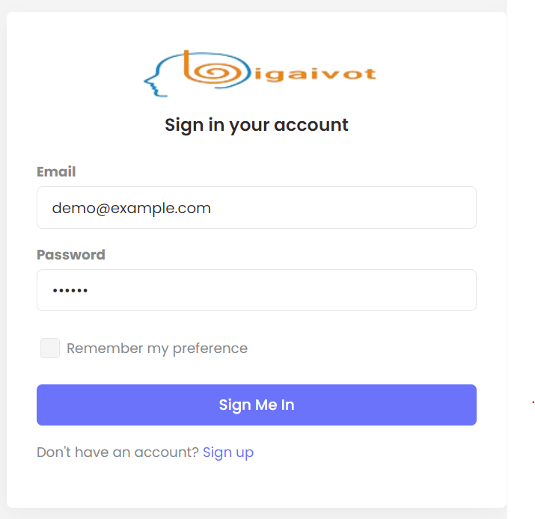
  - Home
    - Connecting Talent
      - This block should express how the product connects the people and organisations for what reasons. 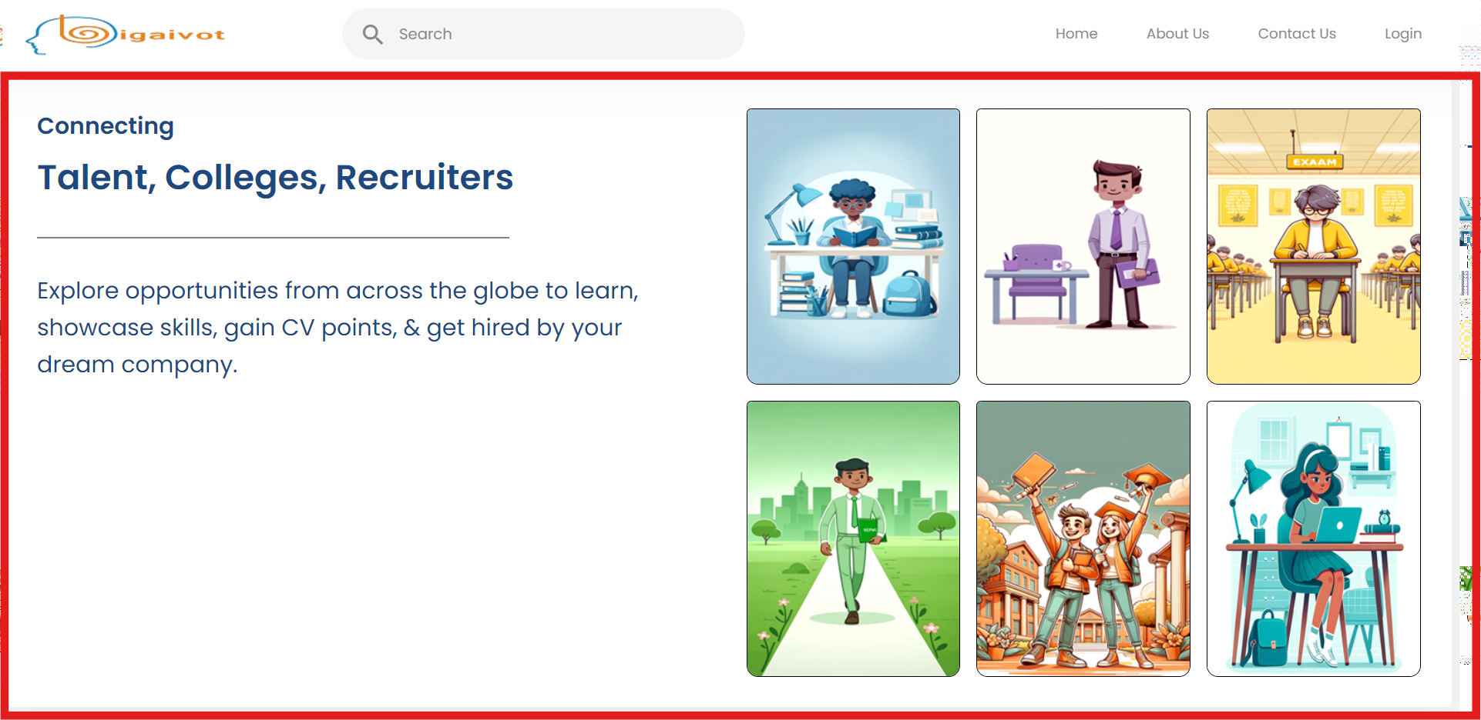
    - Products:
      - This block explains the special features or products (Unique) to the viewers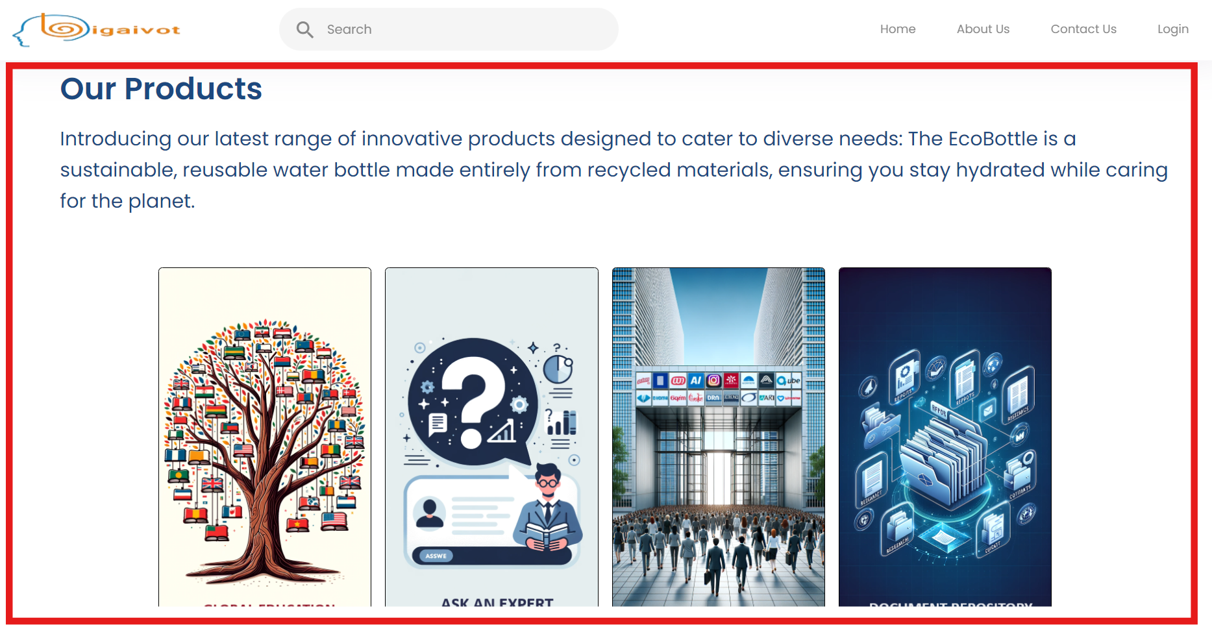
    - Testimonials
      - User and company testimonials should be displayed in carousel mode. And the Super Admin can choose which one to be displayed on the screen.
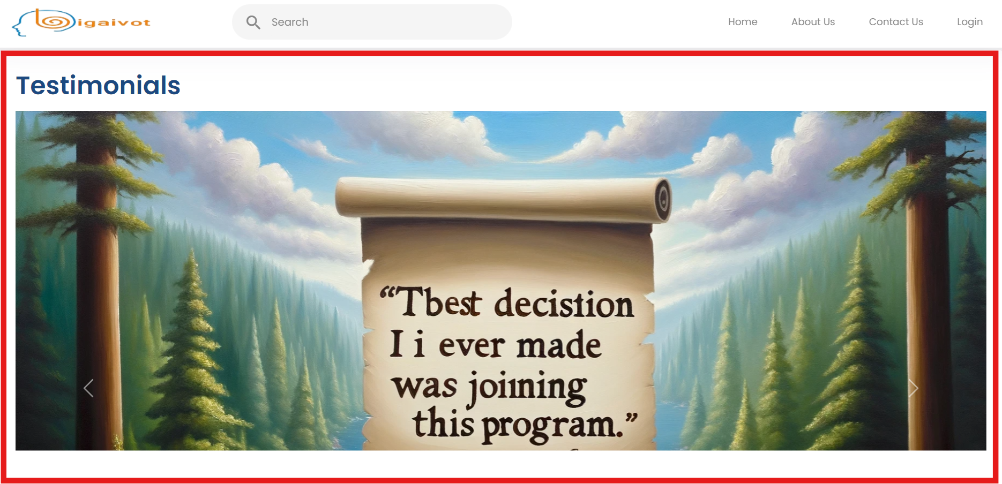
    - Statistics
      - This block should show the statistics like number of users or group enrolled, number of courses published, Number of jobs open etc based on the Admin selection. 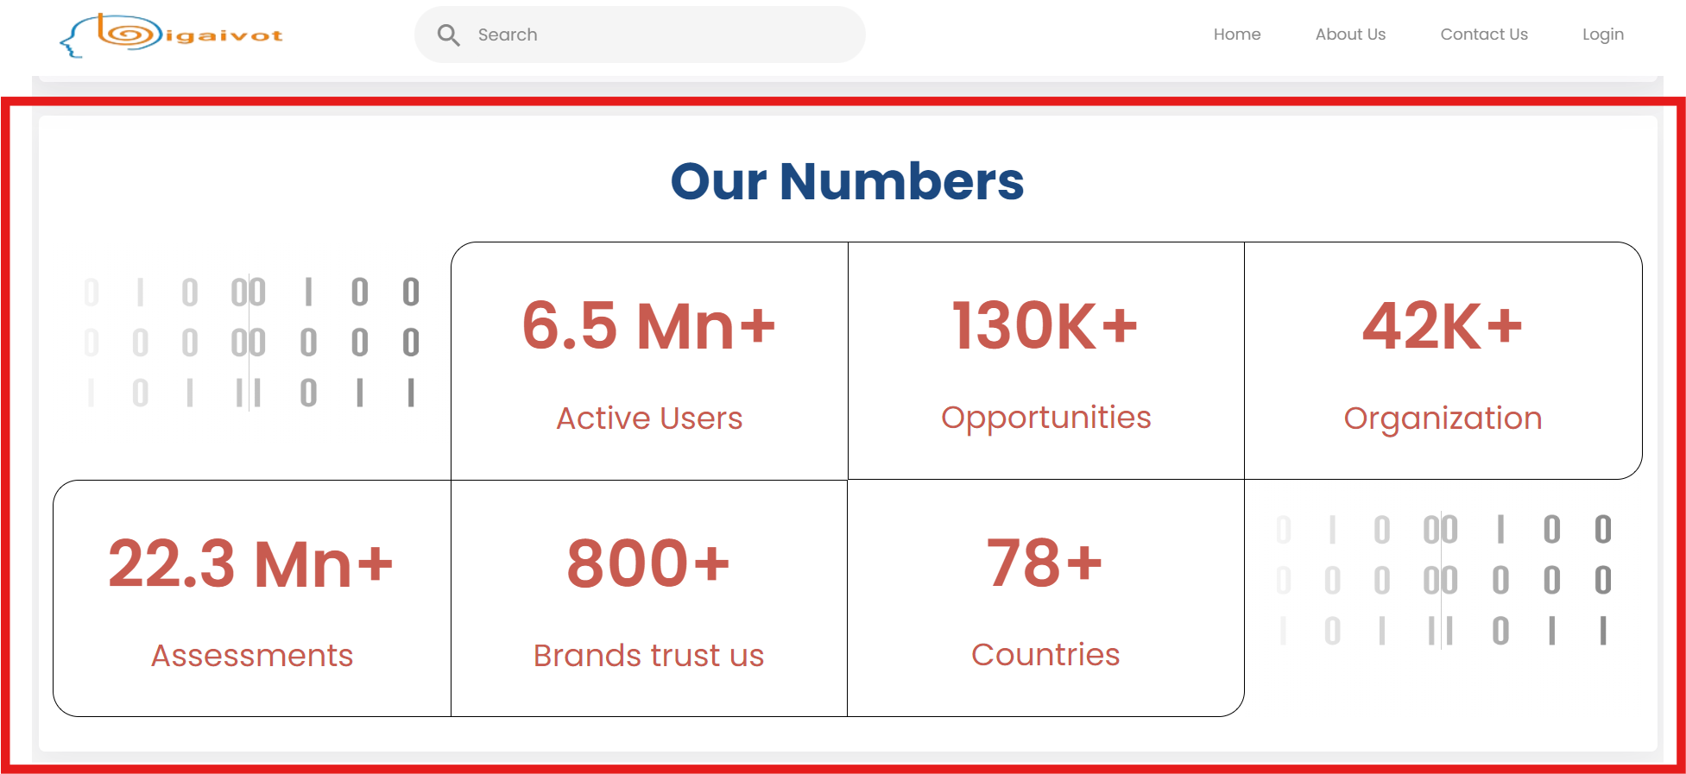
  - Footer
    - Partner with Us
      - Content
    - User Agreement
      - Content
    - Privacy Policy
      - Content
    - Cookie Policy
      - Content
    - Copyright Policy
      - Content
    - Brand Policy
      - Content
    - Community Guidelines
      - Content
    - Languages (Drop down allow to select languages, as of now it should be English)
    - Careers
      - Content
    - Help
      - Content
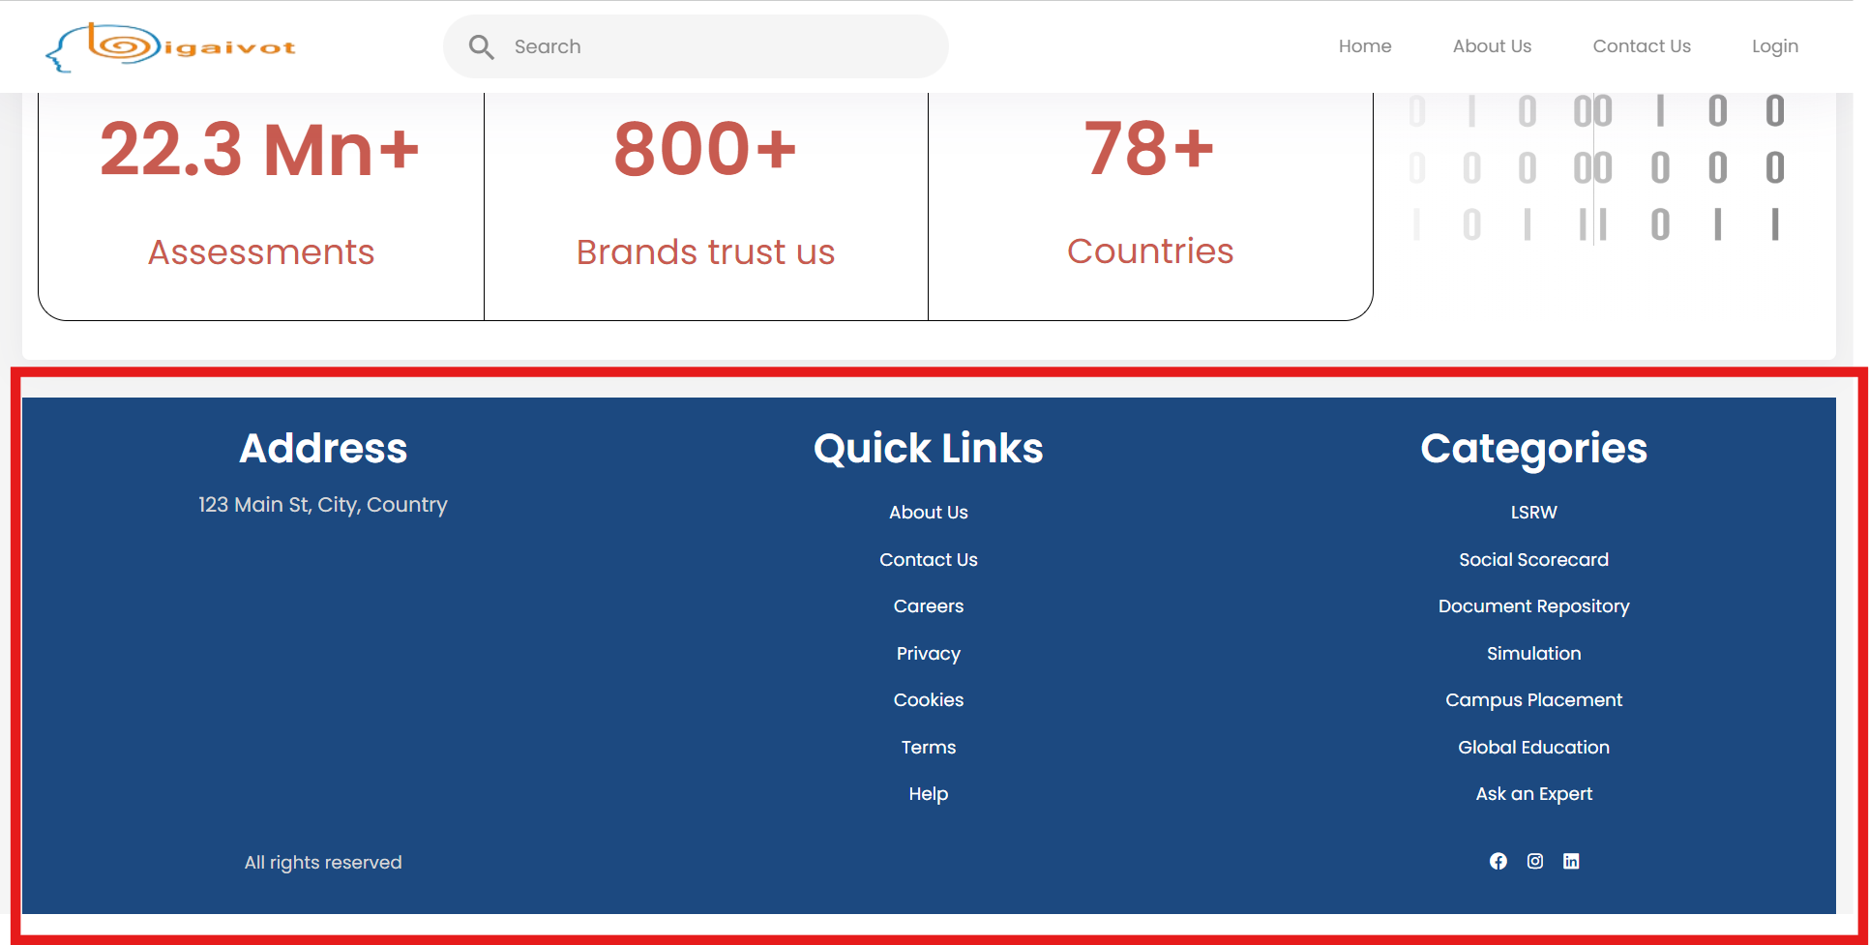

SUPER ADMIN PAGES

Description:
Super Admin controls the complete website, and they will decide who can access and what can be the content in the site.
Super Admin access is secured by the Product owners. Any new login will be notified to the Product owners.

- Super Admin
  - Header Menu:
    - Careers
      - Knowledge Base

    - Analytics
    - Resources

  - Home
    - Dashboard(Interactive)
https://preview.themeforest.net/item/akkhor-school-management-admin-template/full_screen_preview/23687250?_ga=2.237536451.2125939521.1709677237-909289121.1708716390
    - NewsFeed
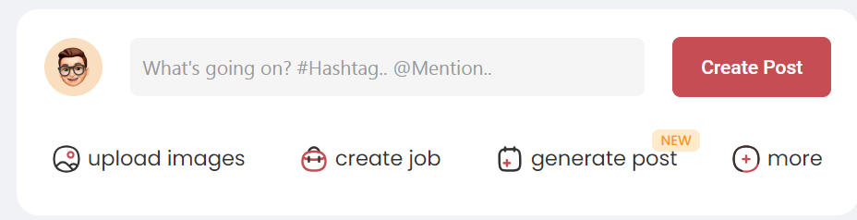
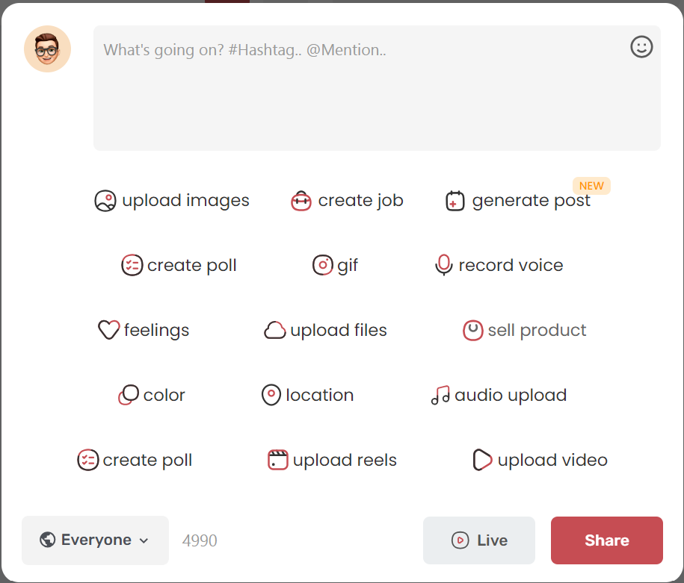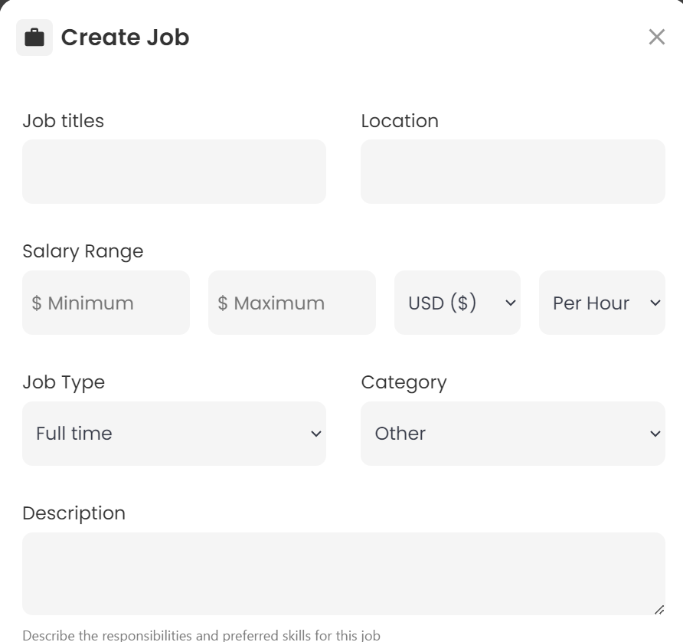
      - Start Post
Start post is just to post a text to the Newsfeed that allows the user to add media’s( Images, Video, Links, documents) in addition it should show add items where the below items are added,
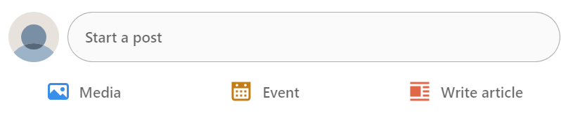

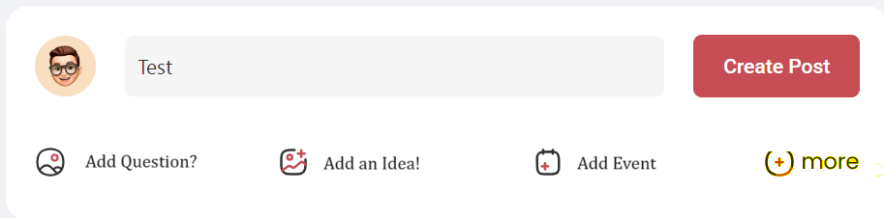
More options:
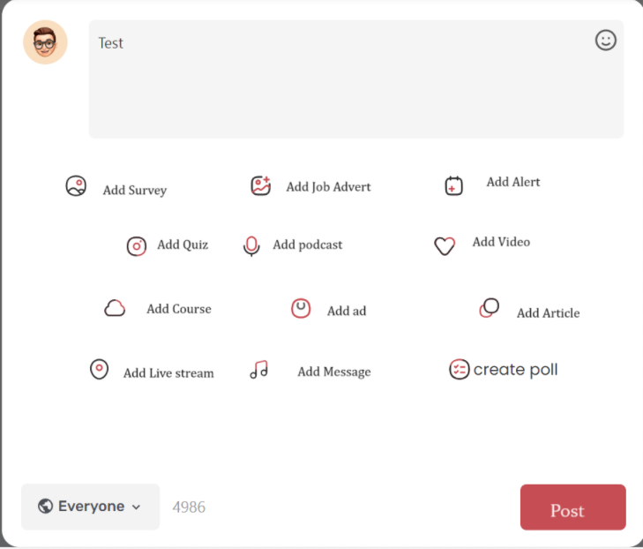
      - All post to be filtered by category and sub category and allow the creator to restrict the population by groups, subgroups, individual users or public.
      - All post have options to add image, docs, url, location through the text editor.
      - All posts are stored in the Knowledge base for future reference that can be segregated on category and sub category.
      - All post have like button(Like, unlike, love, smily), Comments, report and abuse and delete & edit option to creator

        - Add Questions
          - Any post in this category will be posted with all medias but it will go as a question and creator can accept the answer from the comments and accepted comment will be highlighted as Answered and others are highlighted as unanswered.
        - Add Idea
          - Idea will allow the users to comments and feedback on it.
        - Add Poll
          - Add poll allow the users to set the poll answer and the duration of the poll(Optional).
          - Answer visible for all users
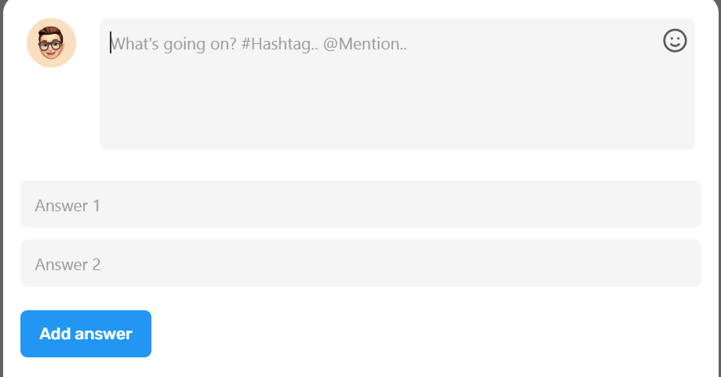
        - Add Survey
          - Add Survey allow the users to go for multiple questions with answer. The answer will visible only to the creator.
        - Add Event
https://www.bannerbear.com/generators/free-online-event-id-card-generator/#generator
          - Add event allow the users to post an event
            - Event name
            - Date and time
            - Registration requires – Redirect to registration page using URL
            - Location
            - Description
            - Last date to register
            - Event organiser
            - Contract of organiser
        - Add Job
          - Add job allow the user to post the jobs
            - Job title
            - Description
            - Skills
            - Start date
            - Expiry date
            - Experience level
            - Job type
            - Salary min and Max
            - Pay type
            - Location
            - Add eligibility questions.
            - Contact
            - URL for career to be applied
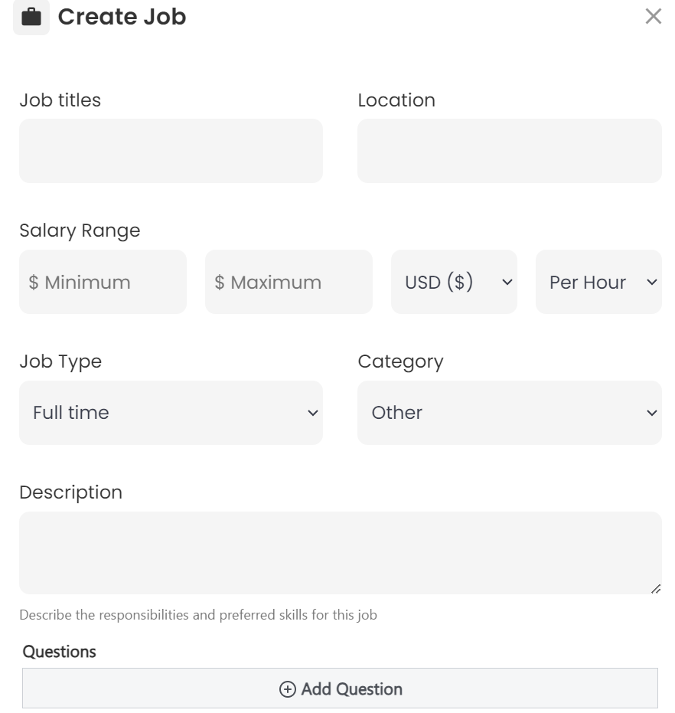
        - Add Alert
          - Alerts will send as two line message maximum chars allowed 190.
          - Alerts will be highlighted on the top of the newsfeed until the user acknowledges
        - Add Live Video
          - Allow users to go live stream. However, the below are mandatory fields
            - Title
            - Registration
            - Start date and time.
            - URL for the Stream
            - Description
        - Add Podcast
          - Title
          - Description
          - URL
        - Add Ad
          - Title
          - Display duration
          - Users are preferred to hide those ad in the newsfeed.
        - Add Quiz
          - Title
          - Description
          - Certificate or not
          - URL to attend the quiz
        - Add Course
          - Title
          - Description
          - URL to the Course(Redirect to the course list -> course summary.
        - Add discussion
          - Title
          - Description
    - Integration Setup
      - Add API
    - Groups
      - Add Groups
      - Add SubGroups
    - Add Users
    - Messages
      - Announcement
      - Alerts
      - Events
      - Messages
      - Polls
      - Survey
      - Notifications
    - Settings
      - Add Permission roles.
      - Picklist
        - Add Category
        - Add Subcategory
        - Add Country
        - Add State/Region
        - Add District/County
        - Add Town/City
        - Add document Type
      - API setup
      - Site Setup
      - Privacy settings
  - Knowledge Base
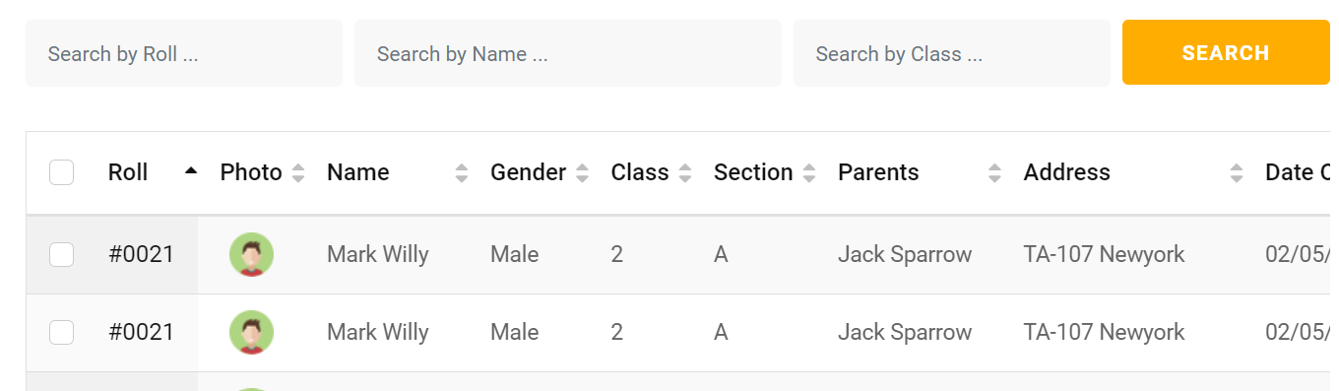
    - Assessment
https://www.bannerbear.com/generators/free-online-certificate-generator/
    - Questions
    - Ideas
    - Books
    - Live Videos
    - Virtual Training
    - Blogs
    - Courses
http://learning.frontendmatter.com/angular/index.html#
    - Discussion forum
  - Careers
    - Post Jobs
      - Posted Job List
      - JD Builder
      - Support Interview
        - Questions
          - General
          - Resume based Questions.
          - Job role-based Questions.

    - Applied Candidates
      - Reports
      - Application Workbench
        - Application Details and Status
  - Tools:
    - Campus Placement and Integration
      - Field to display (With more options)
        - First name
        - Last name
        - Group Name
        - Sub Group
        - Batch
        - CGPA/Percentage
        - Backlogs
        - Skills
        - Soft Skills
        - Assessment Score
        - Technical Score
        - Social Score
        - Skills Experience
        - Language Proficiency
        - Location
        - Location Preferences
        - Graduation Year
        - School Score
        - Extra Curricular
        - Achievement
        - Resume
        - CoverLetter
      - Filter
      - Select to next step
      - Send email
      - Download
      - Send through API
    - Global & Virtual Learning
      - Simulation Games
      - Virtual Training
        - Course list with Filters
          - Filter
            - Course name
            - Category
            - Sub Category
            - Price Type
            - Start Date
            - End date
            - Course type
              - Certificate
              - Assessment
              - Non Assessment
            - Rating
            - Duration
            - Author
            - Level
            - Languages
          - Sort
            - Price High to Low
            - Price Low to High
            - Recently Added
            - Rating High to Low
            - Ration Low to High
            - Expires soon
        - Create Course
          - Title
          - Category
          - Sub Category
          - Tags
          - Course start date
          - Expiry date
          - Price
          - Duration
          - Public or Private
          - Level
            - Beginner
            - Intermediate
            - Expert
          - Curriculum
            - Add Section
            - Add Chapter/lesson
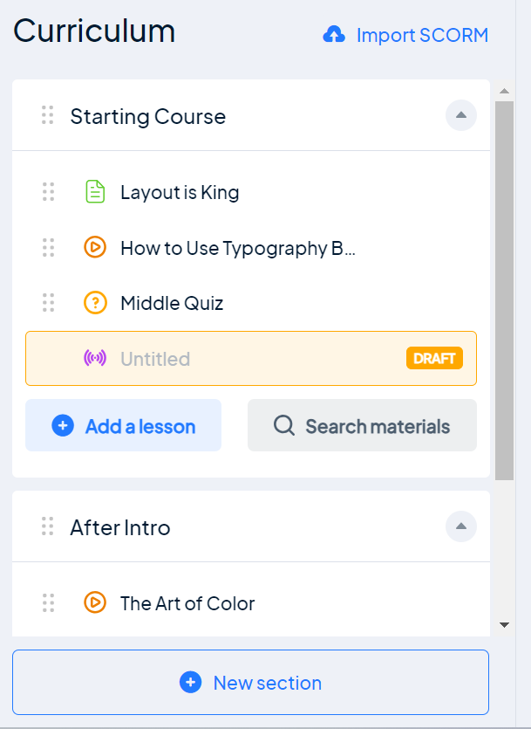
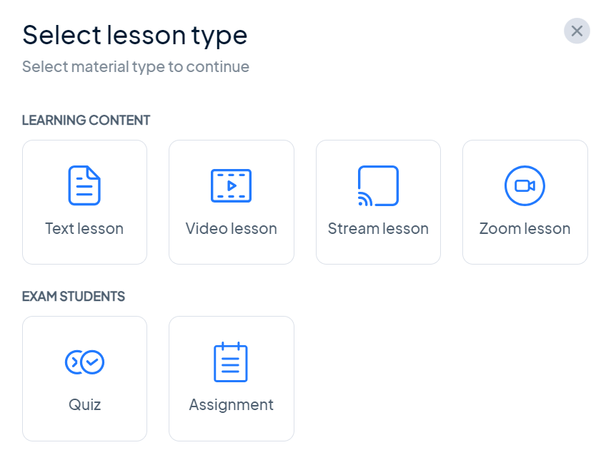
              - Text Lesson
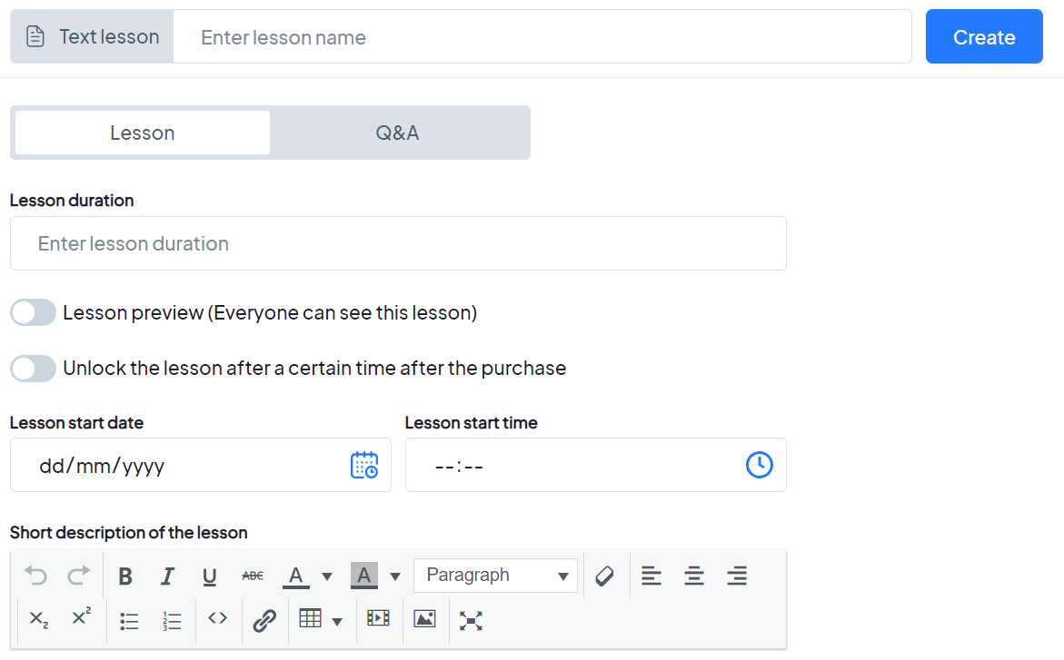
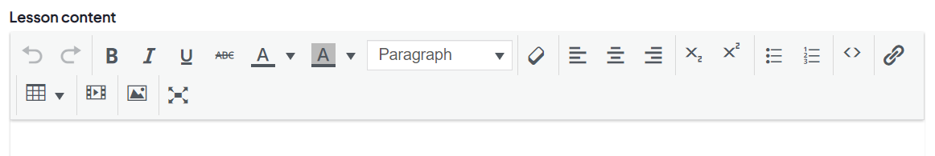
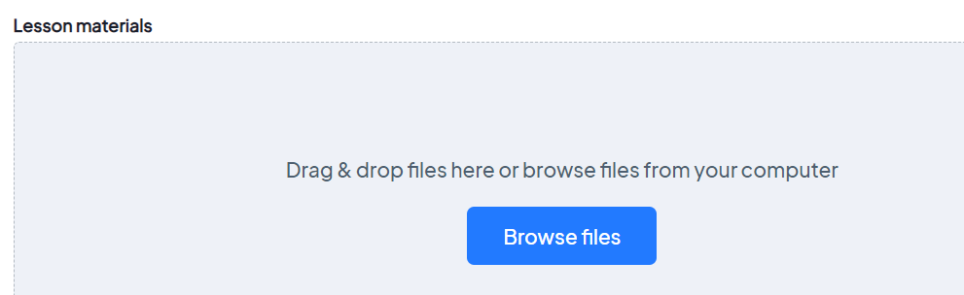
              - Video Lesson
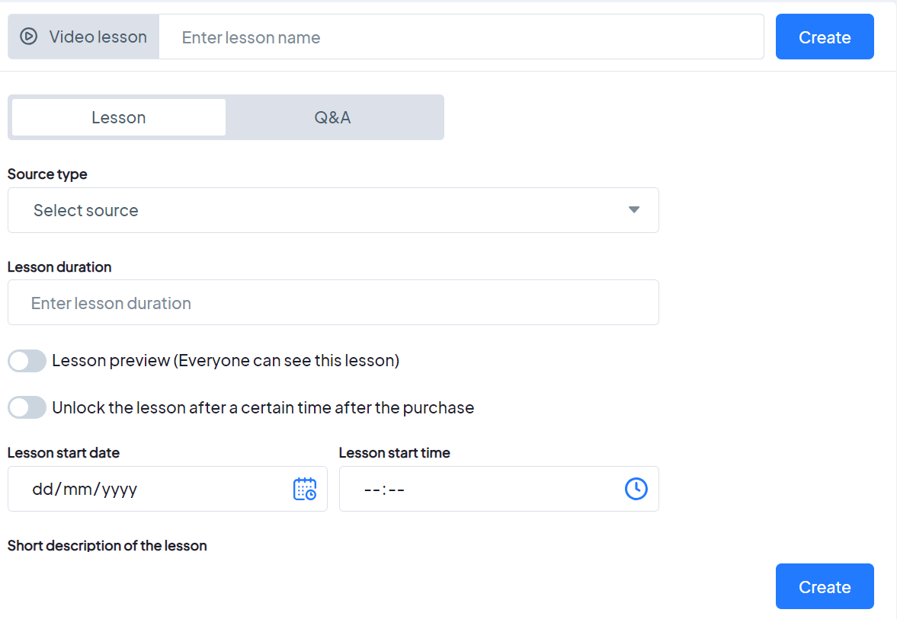
Source Type : Youtube and other websites
              - Stream Lesson
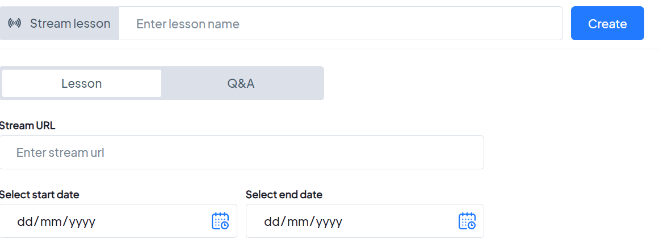
              - URL to Third Party Application
https://masterstudy.stylemixthemes.com/light-lms-elementor/user-account/edit-course/873/curriculum/sections/37/lessons/new?type=stream
              - Lesson Preview
              - Unlock the lesson after a certain time after the purchase
          - Languages
          - Certification
            - Add Certificate template
          - Assessment
            - Add Assessment
          - Overview
          - Instructor
          - Review
          - Feedback/Report
          - Publish
            - Private or Public
            - Private (User or Group selection report to be opened)
        - Manage my Courses
          - My Created Courses
            - Edit, Delete , Activate
          - Enrolled Courses
            - Completion status

- http://learning.frontendmatter.com/angular/index.html#
- https://ymxqfkp.stylemix.dev/user-account/edit-course/881/curriculum/sections/1/lessons/new?type=video
- https://ymxqfkp.stylemix.dev/wp-admin/edit.php?post_type=stm-lessons
- https://preview.themeforest.net/item/edumint-lms-online-courses-education-wordpress-theme/full_screen_preview/50731804?_ga=2.202818713.960463780.1710503760-909289121.1708716390
- https://keenitsolutions.com/products/wordpress/eshkool/courses/english-online-course/

    - LSRW - Deprecated
    - Faculty Assessment – Redirect to Assessment Builder
    - Digital Repository

    - Simulation Games - Deprecated
    - Counselling and Expert advice
      - Book Mentor
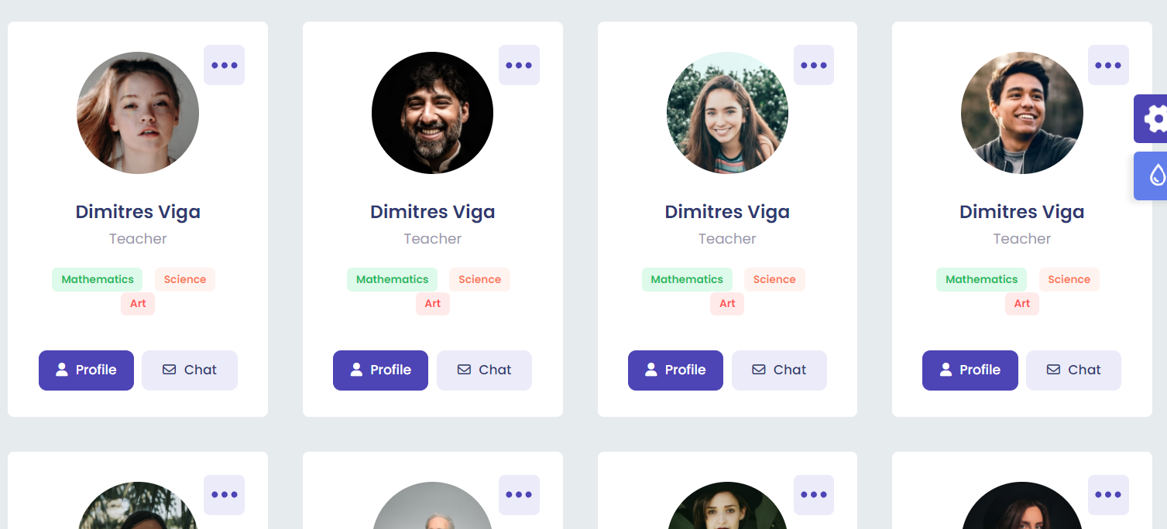
        - Search Mentor
        - Select Mentor
        - Book Appointment
        - Agree on the payment and duration
        - Session
        - Feedback and History log
      - Manage Mentors
    - Social Scorecard
  - Analytics:
    - Reports
  - Contact:
    - Support
    - Feedback
    - FAQ
    - Audit logs

- Group Admin
  - Home
    - Dashboard
    - NewsFeed
    - Profile
      - About Us
      - Add custom page
      - Contact Us
      - Events
      - Gallary
    - Integration Setup
    - Groups
      - Add SubGroups
    - Add Users
    - Messages
      - Announcement
      - Alerts
      - Events
      - Messages
      - Polls
      - Survey
      - Notifications
    - Settings
      - Add Permission roles.
      - Add Category
      - Add Subcategory
      - Group Setup
      - Privacy settings
  - Knowledge Base
    - Assessment
      - Questions
      - Ideas
      - Books
      - Live Videos
      - Courses
      - Podcast
      - Quiz
      - Certifications
    - Discussion forum
  - Careers
    - Post Jobs
      - JD Builder
      - Support Interview
        - Questions
          - General
          - Resume based Questions.
          - Job role-based Questions.

    - Applied Candidates
      - Reports
      - Application Workbench
        - Application Details and Status
  - Tools:
    - Campus Placement and Integration
    - Global & Virtual Learning
    - LSRW
    - Faculty Assessment
    - Digital Repository
    - Simulation Games
    - Counselling and Expert advice
    - Social Scorecard
  - Analytics:
    - Reports
  - Contact:
    - Support
    - Feedback
    - FAQ
    - Audit logs

- Subgroup Admin
  - Home
    - Dashboard
    - NewsFeed
    - Profile
      - About Us
      - Add custom page
      - Contact Us
      - Events
      - Gallary
    - Integration Setup
    - Groups
      - Follow Groups
    - Users
      - User list
      - Followers
    - Messages
      - Announcement
      - Alerts
      - Events
      - Messages
      - Polls
      - Survey
      - Notifications
    - Settings
      - Group Setup
      - Privacy settings
  - Knowledge Base
    - Assessment
      - Questions
      - Ideas
      - Books
      - Live Videos
      - Courses
      - Podcast
      - Quiz
      - Certifications
    - Discussion forum
  - Jobs
    - Post Jobs
      - JD Builder
      - Support Interview
        - Questions
          - General
          - Resume based Questions.
          - Job role-based Questions.

    - Applied Candidates
      - Reports
      - Application Workbench
        - Application Details and Status
  - Tools:
    - Campus Placement and Integration
    - Global & Virtual Learning
    - LSRW
    - Faculty Assessment
    - Digital Repository
    - Simulation Games
    - Counselling and Expert advice
    - Social Scorecard
  - Reports:
    - Reports
  - Contact:
    - Support
    - Feedback
    - FAQ
    - Audit logs

- User
  - Home
    - Dashboard
    - NewsFeed
    - Profile
      - My Report

      - My Profile
      - Personal Bio
        - BA ID
        - Firstname
        - Surname
        - Middle name
        - Date of Birth
        - Nationality
        - Gender
      - Education
        - Degree Type
          - Primary
          - Secondary(10+)
          - Secondary(12+)
          - Diploma
          - Bachelor
          - Masters
          - Doctorate
        - Group Name
        - SubGroup Name
        - Start Date
        - End Date
        - Course completion date
        - Grade Type/Grade
          - Part time
          - Full time
          - Distance education
        - Completion Status
          - Passed
          - Pursuing
          - Extension
        - Group Registration Number
        - Exam Registration Number
      - Experience
        - Employment Type
          - Part time
          - Full time
          - Full time Contractor
          - Part time Contractor
          - Director
        - Group Name
        - Subgroup Name
        - Job Title
        - Start Date
        - End Date
        - Location
        - Location Type
          - Office
          - Home
          - Hybrid
        - Role Description/Achievements
        - Employee Number
      - Skills
        - Skill
        - Start Date
        - End Date
        - Proficiency Level
          - Beginner
          - Intermediate
          - Advance
          - Expert
      - Languages
        - Language
        - Proficiency Type (Multi check box)
          - Speaking
          - Writing
          - Understand
        - Proficiency Level
          - Learning
          - Intermediate
          - Expert
      - Bio Identity
        - Blood Group
        - Height
        - Weight
        - Allergic
        - Diet
      - Contacts
        - Address
        - Contact Number
      - Identity Card
        - Doc Type
          - Passport
          - Driving License
          - Tax Card
          - Visa
          - Work Permit
          - Identity Card

        - ID
        - Start date
        - End date
        - Scanned document (Front and Back pages)
        - Issuing Authority
        - Issuing Country
        - Legit(Yes/No)
      - Global data(With DPCA)
        - Religion
        - Ethnicity
        - Smoking
        - Drinking
      - Other Association:
        - Doc type
          - Insurance Number
          - Club Card
          - Medical Card
          - Postal Card
        - Doc Name
        - Doc Number
        - Start date
        - Expiry date
        - Contact Number
        - Scanned Document
        - Notes
      - Benefits(Govt schemes eligibility, Scholarship, Sponsorship and status)
      - External Apps integration
    - Groups
      - My Group (All groups and Sub groups)
        - Registered Group
        - Subscribed Group
      - All Groups(Including Groups and Sub groups)
    - Messages
      - Announcement
      - Alerts
      - Events
      - Messages
      - Polls
      - Survey
      - Notifications
    - Settings
      - Account Preferences
      - Sign in and Security
      - Visibility settings
      - Notifications settings
      - Privacy Settings
      - Add Permission roles.
      - Add Category
      - Add Sub Category
      - API setup
  - Knowledge Base
    - Assessment
    - Questions
    - Ideas
    - Books
    - Live Videos
    - Courses
    - Discussion forum
  - Jobs
    - Search Jobs
      - Resume Builder
      - Support Interview
        - Tips
        - Interview Preparation
          - Mock interview
        - Questions
          - General
        - Resume based Questions.
        - Job role-based Questions.

    - Applied Jobs
      - Application Details and Status
  - Tools:
    - Campus Placement and Integration
    - Global & Virtual Learning
    - LSRW
    - Faculty Assessment
    - Digital Repository
    - Simulation Games
    - Counselling and Expert advice
    - Social Scorecard
  - Reports:
    - My report
      - Learning Report
      - Audit Log
      - Assessment
      - Activity
  - Contact:
    - Support
    - Feedback
    - FAQ
    - Audit logs

- Cookies and Policy
  - BigAivot and 3rd parties use essential and non-essential cookies to provide, secure, analyze and improve our Services, and to show you relevant ads (including professional and job ads) on and off BigAivot. Learn more in our Cookie Policy..
  - Select Accept to consent or Reject to decline non-essential cookies for this use. You can update your choices at any time in your settings.

Search Bar:

